The diagram/chart can be saved as a file to be shared with family or health care professionals. Click on the “Save as PDF” icon. There are two sets of icons, one below the diagram and one below the chart.

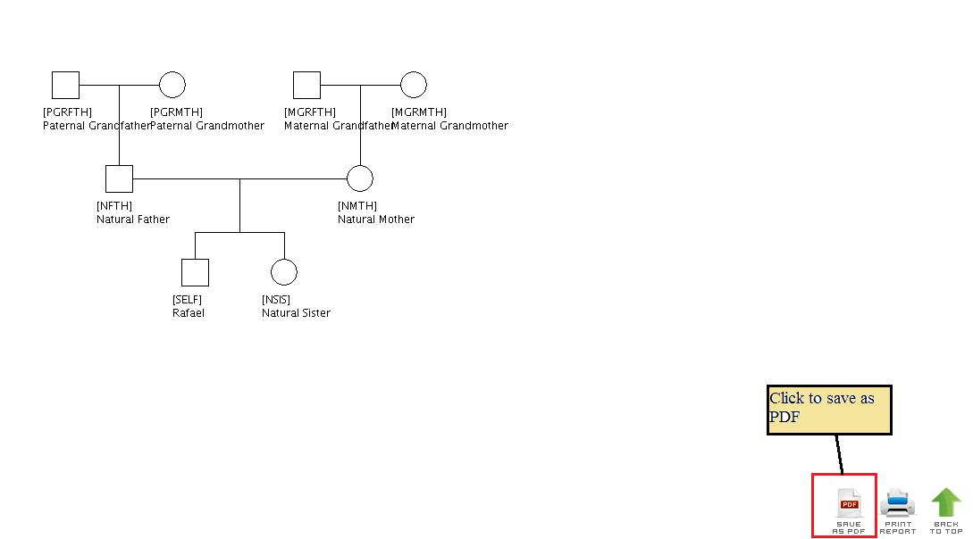

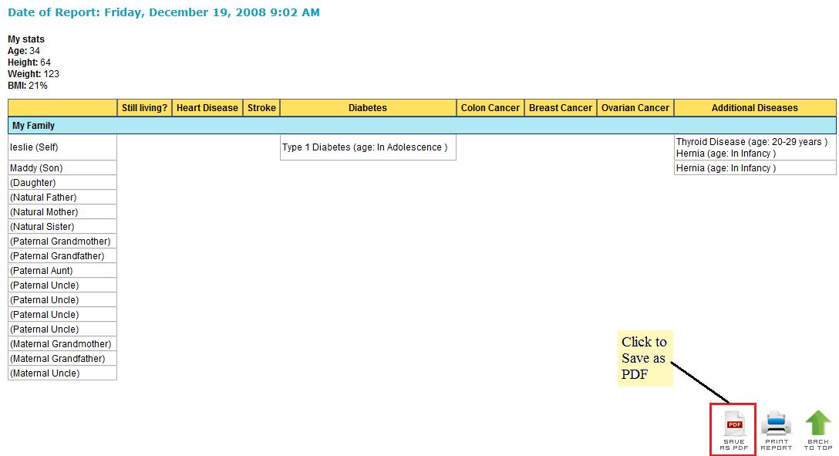

This will open a new window displaying the chart/diagram. You can either save the diagram or print it from the new window.
